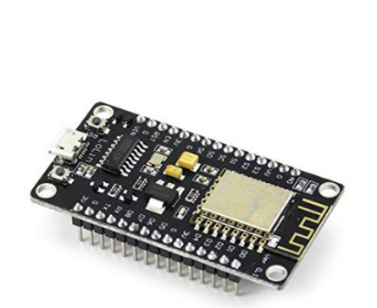ESP8266/NodeMCU

**Description:**

* A small board with built-in Wi-Fi capability. **Function:**
* It acts as the control hub for the system.
* Collects data from the soil moisture sensor.
* Sends commands to the relay module to control the water pump.
* Connects to the internet for remote control or data monitoring.

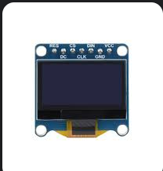 **OLED DISPLAY**

**Description:**

* A small rectangular screen that displays information. **Function:**
* Provides real-time data, such as:
  + Moisture level of the soil.
  + System status (e.g., Wi-Fi connected, pump on/off).
  + Alerts or error messages.

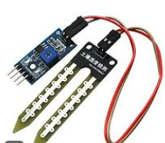

Soil Moisture Sensor

**Description:**

* A sensor with two probes that go into the soil.

**Function:**

* Measures the amount of water present in the soil.
* Sends analog/digital signals to the ESP8266 indicating moisture levels.
* Helps automate watering when soil is too dry.

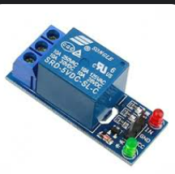

Relay Module

**Description:**

* A small electronic switch with input and output terminals. **Function:**
* Allows the ESP8266 to control high-power devices like the water pump.
* It acts as a safe intermediary between the microcontroller and pump.

Water Pump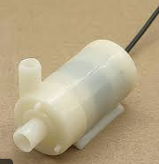

**Description:**

* A miniature pump that pushes water through a connected pipe. **Function:**
* Pumps water into the soil or plant pots.
* Activated by the relay module when watering is needed.

Breadboard and Wires

**Description:**

* A board for temporarily connecting components without soldering. **Function:**
* Provides a platform for wiring connections between the ESP8266, sensors, and other modules.

